**Project Management Workbook**

This material will introduce you to general terms and concepts associated with project management (PM).

When you begin working for a specific organization, you will likely find that these terms and the way they are used may be different at your organization.

**Defining Project Management**

|  |  |
| --- | --- |
| Defining what constitutes a project | A project is an individual or collab endeavor that is planned to achieve an outcome |
| Greenfield | New implementation |
| Brownfield | System conversion |
| Project Management | Effective management of all activities to succeed and complete a project. |

Project Management Result Keywords

|  |  |  |  |
| --- | --- | --- | --- |
|  | |  |  |
| Project Manager | Responsible for managing the process and activities of project management | | |
| Project Charter | Document that provides formal approval to proceed as a project. | | |
| Project Schedule | Project schedule is used for documenting and detailing key milestones. | | |
| Gantt Chart | Shows what must be done and when it should be done. Visual tool used to identify relat4ed timing and predecessor and successor activities. | | |

**Planning**

1. Determine the viability of the proposal. Will the final product create enough value to pay for the project costs and give the organization enough benefit (return on investment) to make the effort worthwhile?
2. Get Project Charter signed off to have organizational commitment to support and pay for the project.
3. Plan out project activities. Ensure that the project is going to be controllable.

**Execution**

1. Collect and plan specific requirements to understand the deliverable.
2. Determine and acquire resources (skill sets) needed to accomplish delivery.
3. Create a schematic or blueprint to detail the build.
4. Perform the work necessary to create a product or prototype.
5. Perform all testing to validate that the deliverable meets the quality and functionality requirements of the customer.
6. Perform testing to validate that introduction of this new product into the environment will not cause harm to the environment or other existing products.
7. Ensure that customers/users are prepared to receive this product (training, user manuals, documentation).
8. Provide a knowledge transfer plan for implementation to execute.
9. Turn over all implementable components to the release process.

**Implementation**

1. Perform all activities necessary to place the product into the live environment.
2. Execute a Knowledge transfer plan to ensure support personnel are ready to support the end customer.
3. Notify the customer/user community as to the availability of the new product or service.
4. Provide support to operations staff and user community as the service is hooked up for actual usage.

**Closure**

1. Finalize documentation for future needs.
2. Pay all outstanding invoices.
3. Validate customer acceptance and satisfaction.
4. Perform any additional activities required to close-out the project.

Nine Areas of Attention

|  |  |
| --- | --- |
| Scope | Define area that needs to be done. How much work and expectations. Quality, Cost, Delivery. |
| Schedule | Control document defining timing for all project activities, including delivery. |
| Cost | Expected and actual Cost |
| Quality | Evaluating the quality of deliverables as they are being designed , and delivered. |
| Risks | Something that might happen , negative or positive but usually mostly negative. |
| Issues | Something that has happened or is happening that is negative |
| Stakeholders | Group impacted by project |
| Administration | Paperwork , meetings, reports. |
| Approvals | Initial , milestone, completion |

|  |  |
| --- | --- |
|  |  |

**Assessing the Importance of a Risk**

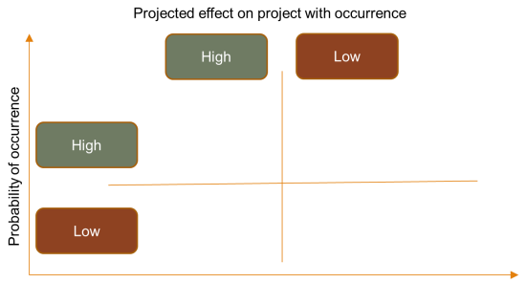

|  |  |
| --- | --- |
| Mitigation  Strategy | Created for any risk deemed probable. Implementing and determining strategy to risk the occurrence should it happen, document both the risk and register. |

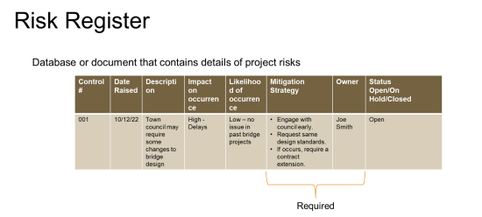

20 most common risk categories of which to be aware of (When one of these categories is identified as being active, you should determine a mitigation strategy as soon as possible):

1. Purchase and Need not well-defined.

2. Incomplete project design and deliverable definition.

3. Difficulty in defining and understanding project schedules.

4. Risk related to budget.

5. Resistance to change.

6. Risks related to resources.

7. Lack of control over staff priorities.

8. Risk factors related to disputes.

9. Unplanned work risk.

10. Communication issues.

11. Risk related to errors.

12. Escalating project conflicts not reported in a timely manner.

13. Delay in projects.

14. Increased workload due to policy changes, direction or statutes.

15. Health and safety.

16. Change in exchange rates.

17. Quality-related risk.

18. Resource supplier’s risk.

19. Risk related to partners.

20. Market-based risk.

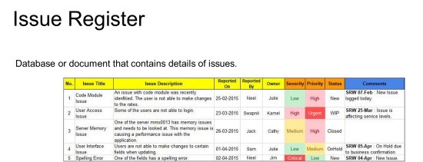

Can a risk also be an issue at the same time? _______

Can this be listed in both the risk register and issue register at the same time? ______

Why or why not?

Yes you can continue to manage risk register and manage issue register because they can boith occur at the same time.

**Relationship of Risk to Issue**



|  |  |
| --- | --- |
| Focus on present  Always negative  Document in issue register  Response will be issue work around | Evaluated for future  Positive or negative  Documented in risk register  Response performed based on risk response planning |

|  |  |
| --- | --- |
| Stakeholder | Stakeholder is entity with interest in outcome of project |
| Customer | Entity who pays for service or product |
| User | Entity that consumes service or product |
| Supplier | Entity that provides products and services used in creation or delivery of products or services. |
| Service Provider | Entity provides to customers and users to enhance business productivity. |

**Factors in determining the level of stakeholder involvement:**

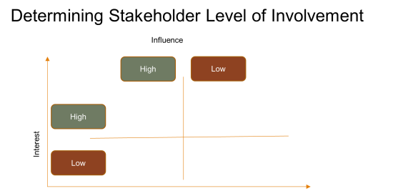

|  |  |
| --- | --- |
| RACI Usage | Tool used to identify stakeholders and involvement in a project or activity. |
| R— | Responsible for correct execution |
| A— | Accountable for final result |
| C— | Consulted to provide additional knowledge and information |
| I— | Informed or kept up to date regarding progress |

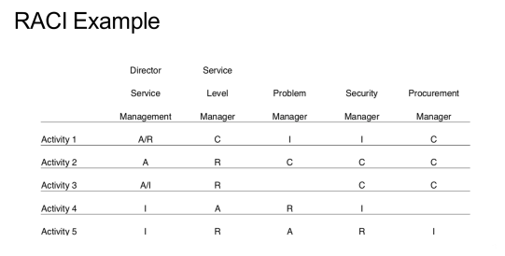

What is the #1 rule for using a RACI matrix?

At least one person responsible and another accountable for each task

**Every business looks to attain three things**

1. _____Achieve objective ___________________
2. _____Manage risks___________________
3. ______Have fully utilized resources __________________

The concept of value is determined by three items:

|  |  |  |
| --- | --- | --- |
| Time to Market | Fierce Competition. | Not responding to Changing Technologies/Conditions. |

Why do we want to control the customer’s perception of the value of our deliverables?

Control pricing. Affordable mix of features. Value changes over time and circumstances.

Utility & Warranty

|  |  |
| --- | --- |
| Use Purpose | Use Purpose |
| Improve Customer performance  Minimize or remove a constraint  Fit for purpose | Correct Availability  Correct Capacity  Correct Continuity  Correct Security  Warranty  Fit For use |

Who’s opinion of value is the only opinion that matters? consumer

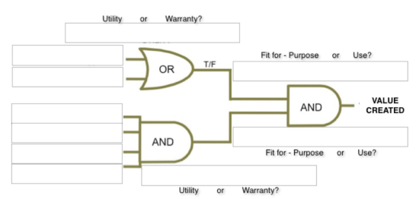What happens when an organization fails to deliver value?

Profitability goes down.

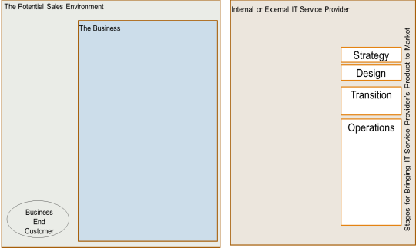

**Service Provider Types**

|  |
| --- |
| Internal Service Provider |
| Shared Services Unit |
| External Service Provider |